AQUAPONICS SALES

MOBILE APPLICATION

“AquaOrder”

**Submitted by:**

Edoo Jameel Mohammad Ibraheem

Daren Devakumaren Baloomoody

Yogheswar Surjoo

Vibahakarsingh Beeharry

**MODULE NAME: GENIE LOGICIEL**

**Université des Mascareignes**

**Faculty of ICT**

**MARCH 2024**

Table of Contents

**1** **| INTRODUCTION** 3

**1.1** **INTRODUCTION** 3

**1.2** **PROBLEM STATEMENT** 4

**1.3** **AIMS AND OBJECTIVES** 5

**2** **| SYSTEM DEVELOPMENT** 6

**2.1** **UML ANALYSIS AND MODELLING** 6

**2.1.1** **Definition of Actors** 6

**2.1.2** **Definition of Use Cases** 7

**2.1.3** **Use Case Diagram** 8

**2.1.4** **Detailed Description of Use Cases** 9

# **1 | INTRODUCTION**

# **INTRODUCTION**

**“**Mauritius is the biggest user of pesticides per area of cropland in the world. Given the scarcity of research on the impact of continued overuse of pesticides on the environment and people’s health on the island, it is urgent to raise awareness about the possible implications of this issue so we can find ways to avert a major ecological disaster.

The latest report from the United Nations Food and Agriculture Organization (FAO) on global trends in pesticide use puts Mauritius at the top of the list of countries that used the most pesticides in 2018 (see Figure 1), with 2795 kg of pesticides used per kmsq of cropland (the latest 2020 statistics gives a record figure of 3418 kg /sqkm, which is a 22.3% increase over the past 3 years).

(RUGHOONAUTH, 2021) **”**

Studies have shown that Mauritius is one of the leading countries in the world when it comes to the use of pesticides and fertilizers per area of cropland in the agricultural industry.

Consequently, Mauritius has seen a significant increase in the amount of small aquaponics farmers in recent years. Aquaponics, a sustainable bio-farming method, has piqued the interest of many Mauritians seeking to adopt a better eating lifestyle. It is often the go to solution for many people in regards to bio-farming, the reason being that it offers a holistic approach to agriculture through the combination of aquaculture and hydroponics to create a self-sustainable system which does not rely on external sources such as chemical fertilizers to stimulate plant growth.

# **1.2 PROBLEM STATEMENT**

The number of people who are opting for a healthier dietary choice has increased over the years due to concerns of high pesticide usage in in the agricultural industry in Mauritius. And one of the main obstacles for members of the general public in that regards, is the difficulty in finding retail locations specialized in selling bio-agricultural products.

In addition to that, most people do not have the time and resources go out of their way to verify whether bio-products being sold on the market. For this reason, many people give up on trying to find better alternatives to the vegetables grown in pesticide heavy environments which are readily available in the local market at much lower prices.

Moreover, markets that do sell bio products are usually scarce and mostly located in urban areas, which restricts their accessibility to many people who do not have the means to travel to such places often to buy their products.

On the other hand, amateur aquaponics practitioners face many challenges when it comes to setting up and running an aquaponics system. One of the difficulties many of them face is that they may not be able to provide a constant supply of products to resellers due to their small-scale production. As such, they are obliged to find buyers from the general public on their own to sell their products to.

This can be a troubling task as the only available options are paid advertising which is expensive and non-profitable, and social media advertising which can be a tedious task for many, assuming they have the time to engage in it.

# **1.3 AIMS AND OBJECTIVES**

The primary objective of this project is to create a mobile application with the purpose of establishing a marketplace for members of the general public who are looking to buy organic products regularly, specifically aquaponics products.

Firstly, the mobile application will be affiliated with an organization dedicated in the promotion and education of either aquaponics or organic farming in general in Mauritius.

The application will allow users to browse the different products and display their availability for each of our distribution points across Mauritius.

Furthermore, users will be able to choose a delivery method which will not require them to move to a distribution point to buy the products; payment can be completed online itself and the delivery address can be specified. In this way, the accessibility of our bio products will not be restricted to people who have the means to go to our distribution locations.

Another advantage members of the public will have is that through the use of our application, members of the public won’t have to worry about whether the products they are buying are authentic, as this process will be the responsibility of the organization.

Finally, the mobile application will help the organization in finding clients all over the island who are interested in buying certified organic aquaponics products, which will ensure that the products of every aquaponics farmer, large-scale or amateur practitioners, will be sold eventually. As a result, these farmers will no longer have to employ other marketing strategies or find clients on their own.

# **2 | SYSTEM DEVELOPMENT**

# **2.1 UML ANALYSIS AND MODELLING**

The system development phase will begin with an analysis of the requirements of the system to accomplish defined tasks within the system.

This will be accomplished using the principles of Unified Modelling Language (UML); more specifically, we will define the actors and use cases within the system along with UML diagrams to provide a visual representation.

# **2.1.1 Definition of Actors**

“Actors can be defined as something that interacts with the system. The actors can be human user, some internal applications or may be some external applications.” (Waykar, 2015)

Actors within the system can be divided into two categories, namely, primary actors and secondary actors.

**Primary Actors**

An actor who requires the development of one or more functionalities within the system to be able to accomplish their defined tasks is referred to as a primary actor.

The mobile application constitutes only of the following primary actors:

* Clients
* System Administrators

# **2.1.2 Definition of Use Cases**

The definition of a use case in light of this project is a written description of a specific task or action which will be performed by the primary actors of the system within the mobile application.

* **The list of use cases for Clients:**

1. User Registration (Sign Up) – Email, NIC, Username, Password
2. User Authentication (Sign In) – Username/Email, Password
3. View & Edit their Profile Page – Input Delivery Address & Contact Details
4. Browse Products – View Quantity Available & Pickup Location
5. Place Orders – Specify Amount, Delivery/Pickup, Payment Mode (On-Delivery/Online)
6. Complete Payment (If Chosen Online Mode)

* **The list of use cases for System Administrators**:

1. User Authentication (Admin Login)
2. Add/Remove Primary Sites (Distribution Points & Store Locations)
3. Product Management (Create, Remove, Edit) – Name, Category, Image, Details
4. Stock Management for each site. (Stock In, Stock Out, Stock Transfer)
5. Receive & Approve/Reject Client Registrations
6. Search & View Client Profiles – NIC, Name, Email, Delivery Address, Contact Details
7. Receive & Approve/Reject Client Orders

# **2.1.3 Use Case Diagram**

The purpose of a use case diagram is to produce a visual representation of the operational mechanism of the web application and its use cases in relation to the actors of the system.

This diagram facilitates the development process since the developer can clearly see the interactions between the different parts of the system.

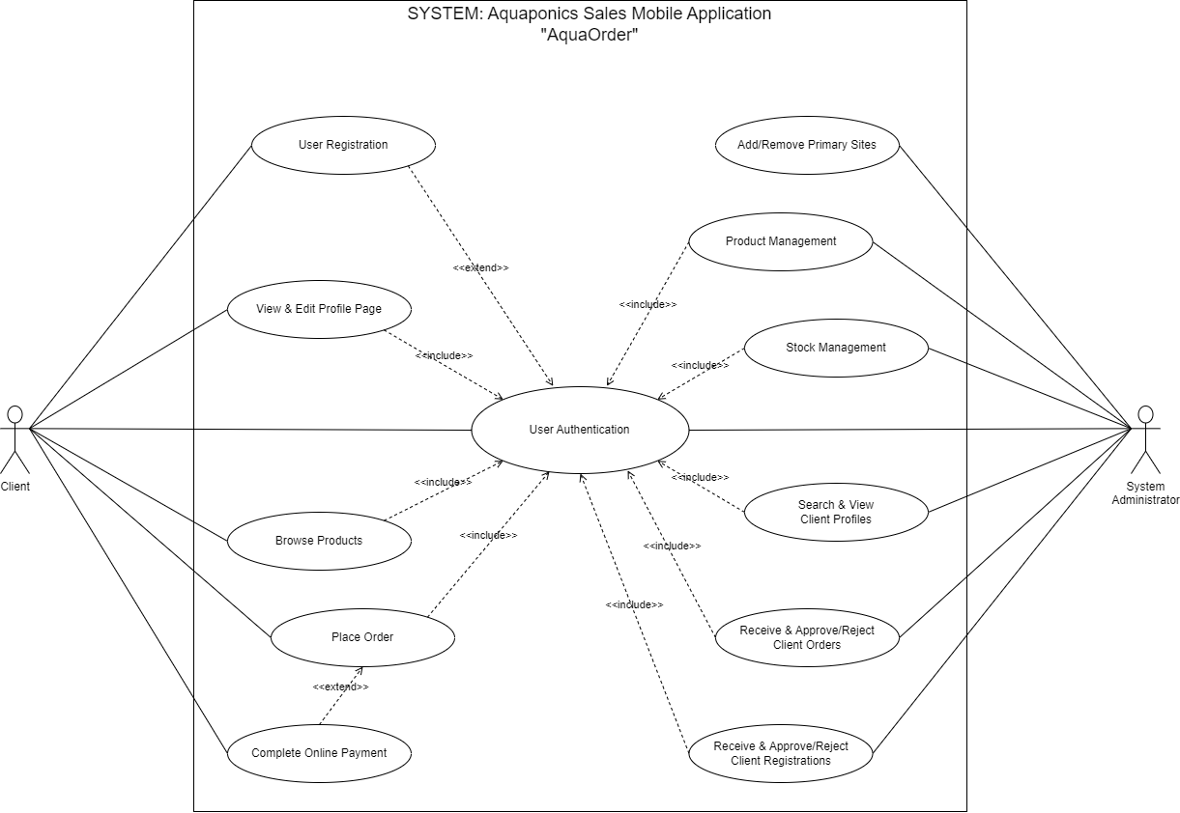

**Figure 1: Use Case Diagram**

# 

# **2.1.4 Detailed Description of Use Cases**

# References

RUGHOONAUTH, N. C. (2021, September 28). *The Scourge of Pesticides Overuse in Mauritius – How Far are we in the Ongoing Ecological Disaster?* Retrieved from charlestelfaircentre: https://charlestelfaircentre.com/the-scourge-of-pesticides-overuse-in-mauritius-how-far-are-we-in-the-ongoing-ecological-disaster/

Waykar, Y. (2015). role of use case diagram in software development. *International Journal of Management and Economics*.